Fingerprint sensor interfacing with raspberry pi

SUBMITTED BY:

K. NAVEEN (18BCE7323)

D. DINESH (18BCE7247)

CH.Rutwik(18BCN7039)

N. BHARATH (18BEC7077)

SK.Imran(18MIS7190)

G.Vamsi (18bcn7071)

Under the guidance of: prof. Ravisankar barpanda

Summary of the project:

**Fingerprint Sensor,** which we used to see in Sci-Fi movies few years back, is now become very common to verify the identity of a person for various purposes. In present time we can see fingerprint-based systems everywhere in our daily life like for attendance in offices, employee verification in banks, for cash withdrawal or deposits in ATMs, for identity verification in government offices etc. Today we are going to **interface FingerPrint Sensor with Raspberry Pi**. Using this Raspberry Pi FingerPrint System, we can enroll new finger prints in the system and can delete the already fed finger prints.

* .

I. INTRODUCTION

We completed our project by going through these steps,

• We made a USB to Serial Programmer,

• We did the basic circuit on breadboard.

• To make the project user friendly, we worked using Display

The basic function of this fingerprint sensor is to store the fingerprint of a particular person and grant access when that particular person’s fingerprint is recognised.

Circuit diagram and explanation:-

In this **Raspberry Pi FingerPrint sensor interfacing project**, we have used a **4 push buttons**: one for enrolling the new fingerprint, one for deleting the already fed fingerprints and rest two for increment/decrement the position of already fed Finger prints. A **LED** is used for indication that fingerprint sensor is ready to take finger for matching. Here we have used a fingerprint module which works on UART. So here we have interfaced this fingerprint module with Raspberry Pi using a **USB to Serial converter**.

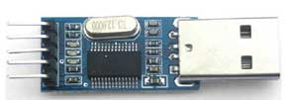

So, first of all, we need to make the all the required connection as shown in Circuit Diagram below. Connections are simple, we have just connected fingerprint module to Raspberry Pi USB port by using USB to Serial converter. A 16*2 is used for displaying all messages. A 10k pot is also used with LCD for controlling the contrast of the same. 16x2 LCD pins RS, EN, d4, d5, d6, and d7 are connected with GPIO Pin 18, 23, 24, 25, 8 and 7 of Raspberry Pi respectively. Four push buttons are connected to GPIO Pin 5, 6, 13 and 19 of Raspberry Pi. LED is also connected at pin 26 of RPI.

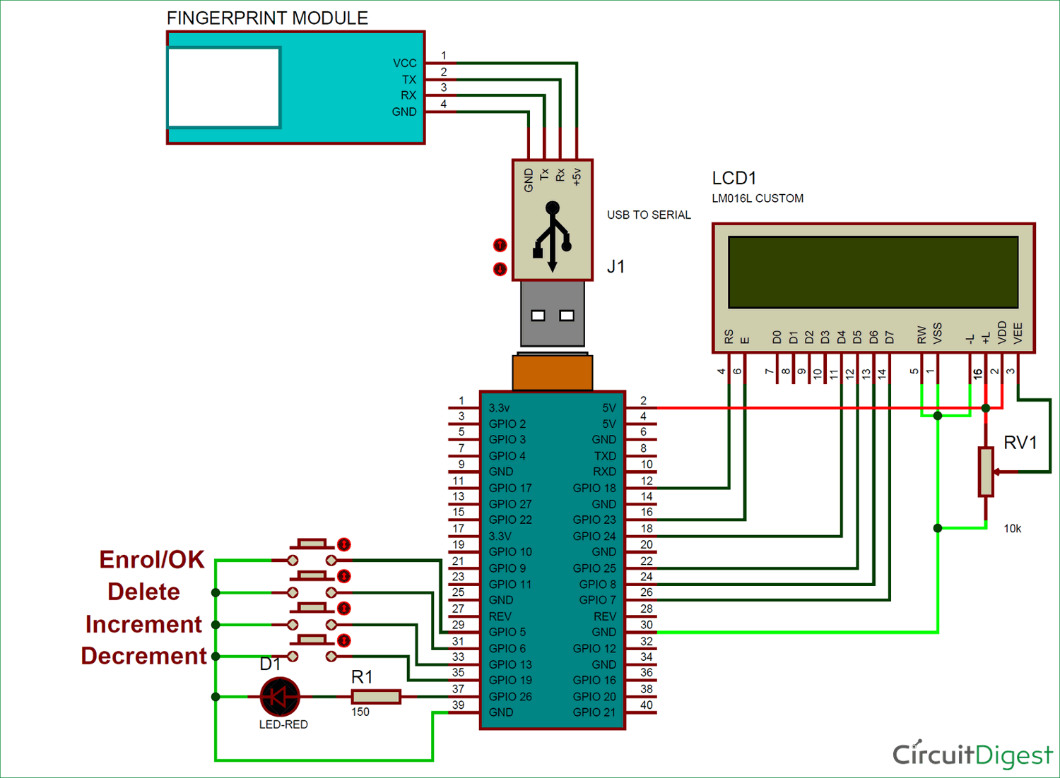

PROBLEM STATEMENT: -

In general, it is the most important That Authorization Plays a crucial role in many of the security that most trusted. The fingerprint sensor gives authentication only when that particular finger is recognised, so it is very secured.

Moreover, resources are very important in this developing era. And one cannot afford wasting so much of Loss and resources in finding Security misconfigurations caused no proper security. Thus there is a need to develop a low cost and easy maintainable, user friendly Fingerprint sensor.

OBJECTIVES: -

This project intends to check whether the produced Fingerprint is Available or not that makes the security more trusted.The makes the users trust the security about both the authentication and authorization.

METHODOLOGY (OR) PROCEDURE: -

### installing Library for FingerPrint Sensor:

After making all the connections we need to power up Raspberry Pi and get it ready with terminal open. Now we need to **install fingerprint library for Raspberry Pi** in python language by following the below steps.

**Step 1:** To install this library, root privileges are required. So first we enter in *root* by given command:

Sudo bash

**Step 2:** Then **download some required packages** by using given commands:

wget –O –<http://apt.pm-codeworks.de/pm-codeworks.de.gpg>| apt-key add –

wget [http://apt.pm-codeworks.de/pm-codeworks.list -P /etc/apt/sources.list.d/](http://apt.pm-codeworks.de/pm-codeworks.list%20-P%20/etc/apt/sources.list.d/)

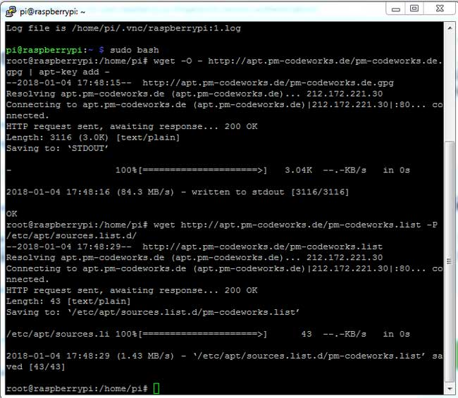

**Step 3:** After this, we need to **update the Raspberry pi and install the downloaded fingerprint sensor library**:

sudo apt-get update

sudo apt-get install python-fingerprint –yes

**Step 4:** After installing library now we need to **check USB port** on which your finger print sensor is connected, by using given the command:

ls /dev/ttyUSB*

### Operation of Fingerprint Sensor with Raspberry Pi:

Operation of this project is simple, just run the python code and there will be some intro messages over LCD and then user will be asked to ***Place Finger*** on FingerPrint Sensor. Now by putting a finger over fingerprint module, we can check whether our fingerprints are already stored or not. If your fingerprint is stored then LCD will show the message with the storing position of fingerprint like **‘*Fount at Pos:2’*** otherwise it will show ***‘No Match Found’*.**

**Now to enroll a fingerPrint, user needs to press enroll button and follow the instructions messages on LCD screen.**

**If the user wants to delete any of fingerprints then the user needs to press *delete button.* After which, LCD will ask for the position of the fingerprint which is to be deleted. Now by using another two push button for increment and decrement, user can select the position of saved FingerPrint and press enroll button (at this time enroll button behave as Ok button) to delete that fingerprint. For more understanding have a look at the video given at the end of the project.**

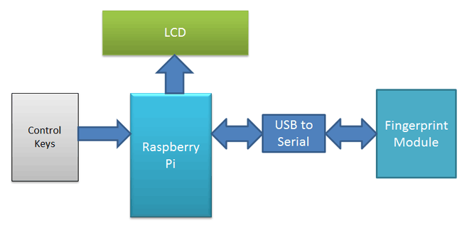RESULTS: -

Following figures are the results of the developed system that displays corresponding results onDisplay. We can see all the Display messages like welcome, Asking for Fingerprint and the message of successful or not.

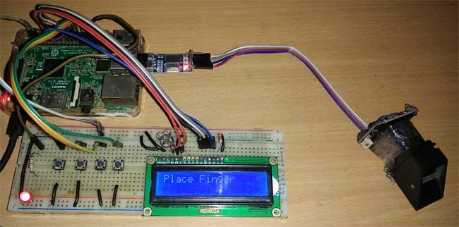

After running the code successfully, The lcd display displays the Welcome screen where, we are able to use push buttons for enrolling or deleting.

CONCLUSION: -

We can operate the Fingerprint sensor or the code with push buttons placed on the breadboard where the connection are made with Raspberry Pi and gives result of required field. The model is user friendly to use and easy to maintain. It reduces time to recognise as we are testing it automatically compared to manually where various connections and application inputs is done. It is also economically efficient.

FUTURE SCOPE: -

This can be further developed to automatic system rather than manual system used here as it is reconfigurable. The developed Fingerprint sensor is useful for educational purpose, but further advance development can make it efficient for Security purpose.

REFERENCES:-

**1.**[**https://circuitdigest.com/microcontroller-projects/raspberry-pi-fingerprint-sensor-interfacing**](https://circuitdigest.com/microcontroller-projects/raspberry-pi-fingerprint-sensor-interfacing)

**2.**[**https://www.raspberrypi.org/blog/raspireader-fingerprint-scanner/**](https://www.raspberrypi.org/blog/raspireader-fingerprint-scanner/)